IT MANAGEMENT SYSTEMS

**Supporting materials IFS Application system**

# Introduction

Every production system is a logistics system for which, by definition, one of the control goals is to place the right products in the right place, at the right time, in the right quantity and in the right way. The decisions of the control system answer the questions of what, where, when, how much and how to produce. Finding the answers to these questions determines all material flows and inventory fluctuations within the company. The order in which decisions are made about what, where, when, how much and how to produce fundamentally influences the operation of the production control system. If it is first decided where, i.e. in which organizational units, production will take place, and only then decisions are made about what, how, when and how much each unit is to produce, we are talking about capacity-oriented production control. This approach is typical for repetitive, mass or large-scale production. However, if first decisions are made about what, how, when and how much to produce, and only then the allocation of production cells to production orders is made, we are dealing with material-oriented production control. Material-oriented production control is characteristic of medium-series, short-series and unit production. Discrete manufacturing systems are characterized by a very large number of variables describing the state of the system, including information about machines, manufactured products, materials, operations, etc. Decision problems occurring in discrete production control systems can therefore be very complex in terms of size as well as the nature of interconnections. The development of IT techniques, both in the field of hardware and database technology or operating systems, and on the other hand, the formulation of theoretical foundations of production management, such as the MRP (Material Requirement Planning) or JIT (Just in time) method, enabled the creation of CIM (Computer Integrated manufacturing). One of the elements of CIM systems are computer-integrated enterprise management support systems of the MRP II (Manufacturing Resource Planning) or ERP (Enterprise Resource Planning) class.

# Logistics system of an industrial enterprise

Currently, logistics deals primarily with the design and management of product production and distribution systems. Very often, elements of these systems are like such as supplies, production plants and commercial warehouses - are scattered over a certain area. Therefore, the main problems of logistics are transport organization and inventory management. However, the production process itself is also important. A simplified diagram of the logistics system for an industrial enterprise is shown in Fig. 1.



Fig. 1. Logistics system of an industrial enterprise

The basic component of the production process in an industrial enterprise is the technological process, while transport and inventory management are treated as auxiliary processes. It is no less convenient to operate in this area with logistics categories.

Depending on the product range produced and the production volume in the enterprise, different types of production can be distinguished. The most common are multi-version, repeatable production, assembly to customer's order and unique production. A given type of production is associated with a logistics system, including a production planning system. Production plans are based on demand forecasts and customer orders, and the share of forecasts and orders in planning varies for different types of production

# Hierarchical structures in integrated production management systems

In modern industrial enterprises, decisions are made by management employees, most often supported by appropriate IT systems. The use of IT enables an increase in the amount of information processed and, as a result, the number and speed of decisions made. Despite the use of IT, the number of variables and data controlled by the management system is too large. Therefore, a hierarchical structure of such systems is necessary, in which detailed decisions are made by different employees at different levels and are coordinated through the decisions of superiors. This results in the organizational hierarchy of the company's production units.

The literature mentions six organizational levels:

* + Workstation
  + Nest or production line
  + Production branch
  + Production department
  + Production facility
  + Industrial enterprise

Not every company has all the organizational levels mentioned above. A 4-tier structure is often found in practice:

* + Position
  + Line or socket
  + Department
  + Undertaking

In IT systems intended to support management in industrial enterprises, the existence of a three-tier production structure is most often assumed:

* Position
* Cell
* Undertaking.

A characteristic feature of these systems is that the company's inventory file does not record materials or elements circulating within the production cell. Most often, a production cell is defined as: a production line, a production cell, etc.

# Bill of materials (Product structure)

To determine the demand for materials, semi-finished products, etc. per unit of product, certain constant data from technology are necessary. A key role here is played by the so-called bill of materials.

Bills of materials (product structures) for all products from the inventory list indicate what and in what quantity is used to produce a given product.

It is obvious that many products are components that are both components of larger assemblies and parent items for their components. Therefore, the material lists are multi-level and graphically presented resemble an inverted tree (Fig. 2). These reports make it possible to determine the demand for a given component depending on the demand for the final product or superior item.

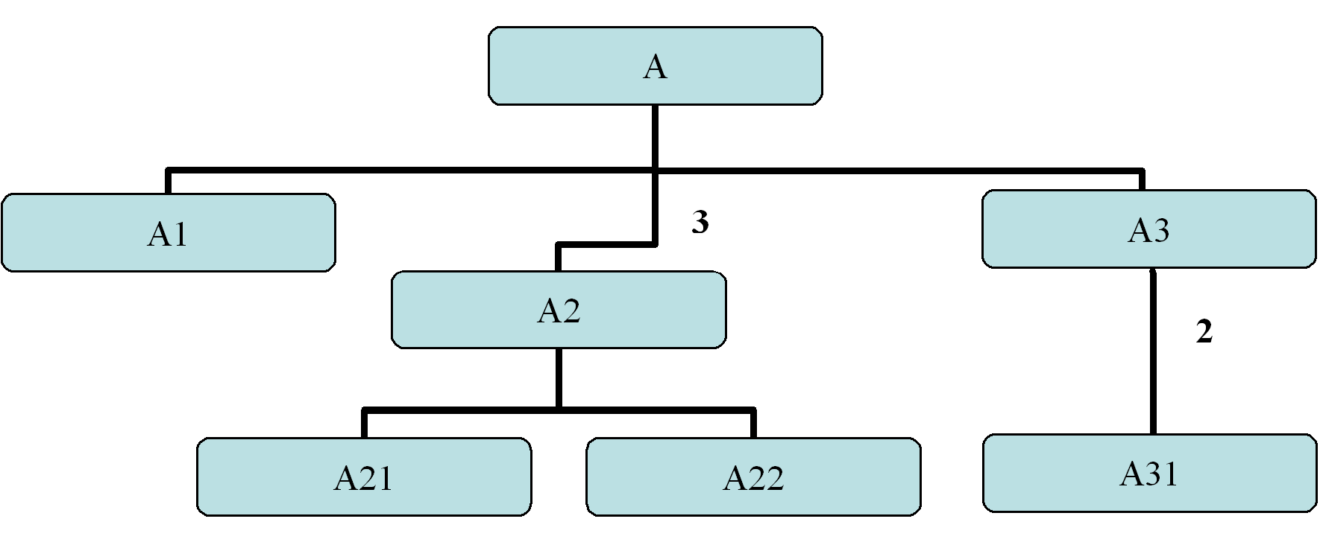

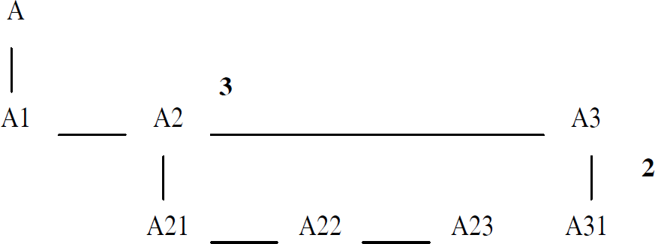

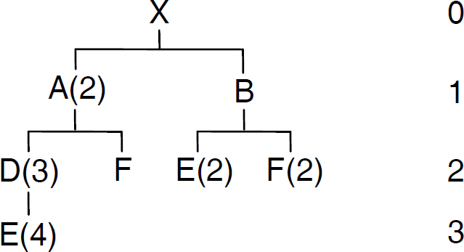

Fig. 2 Various ways of graphically presenting the bill of materials (product structure).

# Production route

The production of a superior item or a final product requires going through several stages of work. These stages are called operations that are performed at subsequent stations (production cells). The purpose of individual operations is to produce a parent item from the components that make up its structure. Production routes are used.

A production route is a sequence of operations performed in the appropriate order on specific machines set up inside production cells associated with a given material index item.

To enter an operation, you usually need to provide its production factor, i.e. the estimated duration of the production process. A unit of measurement is also defined to determine the production lead time. You can select from the following options: Hours/unit, Unit/hour, Hours.

# Design of an exemplary factory based on a PC assembly plant

The design of an exemplary factory or the implementation of a real one in an IT management system must begin with the specification of the project scope and then with the determination of constant data. For the purposes of classes on the subject "Information Management Systems", the scope of implementation can be assumed as in the Table. I. Individual colors (shades) define implementation stages. The implementation begins with the definition of permanent factory data, then the area related to supply and sales /distribution/. The next stage is to enter orders and launch production flow planning and control algorithms.

Table I: the scope of implementation of the sample factory

|  |
| --- |
| 1. Defining warehouses. 2. Introduction of inventory items. 3. Defining product structures for warehouse items 4. Defining departments 5. Defining production cells 6. Defining production cells. 7. Introduction of routes. |
| 1. Defining the people required in the system to carry out purchasing operations 2. Determining purchase items and their suppliers 3. Acceptance and approval of offers. 4. Creating a contract with a supplier 5. Ordering and receiving purchase items |
| 13. Issuing production orders. |
| 1. Issuing materials for a production order. 2. Receipt of items produced to order into the warehouse. 3. Running the MRP algorithm. 4. MRP report printout |
| 1. Defining the people required in the system to carry out purchasing operations 2. Determination of items sold 3. Defining customers. 4. Creating contracts with clients 5. Creating customer orders |

|  |  |
| --- | --- |
|  | Permanent data |
|  | Purchase Data |
|  | Data related to production planning and control |
|  | Sales related data |

The first stage of the project, i.e. the development of permanent data, will be shown on the example of a computer assembly plant.

# General structure of a computer assembly plant

The general diagram of the computer assembly plant, which consists of one assembly department.

Three types of computer sets are assembled and packed in this department:

* + - minimal set,
    - standard set,
    - set max.

Each set differs in the components it contains. The assembly department has the following production cells:

* + - mounting motherboards
    - initial assembly of the housing
    - computer assembly
    - packing your computer

The assembly department is supplied through procurement and production flows to the finished products warehouse.

# Material flow through the assembly department

# Example

The assembly department consists of 4 production cells: K01 - board assembly cell, K02 - housing assembly cell, K03 - computer assembly cell, K04 - computer packaging cell. Fig. 3 shows the flow of materials through the assembly department. The computer assembly process begins in two cells in parallel. In cell K01 where motherboards are mounted and in cell K02 where cases are mounted. Both cells are powered by parts/components from procurement. Semi-finished products from these cells (cases and boards) then go to cell K03. Parts from the supply needed to assemble the complete set are also brought here. Materials are also taken from supplies to cell K04, where the packing process of sets produced in cell K03 takes place. The assembly process ends in cell K04, from which finished products come out. Obraz zawierający diagram, szkic, Rysunek techniczny, Plan

Fig. 3. Material flow through the assembly department

# Material index (inventory list) for a computer assembly plant

For the assembly department, the material index is presented in table 2. In the department, semi-finished products are motherboard + parts, casing + parts, computer. The final product is a packaged computer.

Table 2. Material index for PC assembly plants

|  |  |  |
| --- | --- | --- |
| **Material index** | | |
| **and** | **name** | **type** |
| 100 | packaged computer 1 | 1 |
| 107 | packaged computer 2 | 1 |
| 108 | packaged computer 3 | 1 |
| 101 | adhesive tape | 2 |
| 102 | box | 2 |
| 103 | documentation | 2 |
| 104 | power cable | 2 |
| 105 | styrofoam | 2 |
| 106 | foil | 2 |
| 200 | computer 1 | 1 |
| 252 | computer 2 | 1 |
| 253 | computer 3 | 1 |
| 201 | the tape is coming | 2 |
| 202 | fdd tape | 2 |
| 203 | housing cover | 2 |
| 204 | modem | 2 |
| 211 | 10Mbit network card | 2 |
| 212 | 100Mbit network card | 2 |
| 213 | 1000Mbit network card | 2 |
| 221 | stereo music card | 2 |
| 222 | 4+1 music card | 2 |
| 223 | 5+1 music card | 2 |
| 231 | 64 MB graphics card | 2 |
| 232 | graphics card 128 MB | 2 |
| 233 | graphics card 256 MB | 2 |
| 300 | motherboard+parts 1 | 1 |
| 304 | motherboard+parts 2 | 1 |
| 305 | motherboard+parts 3 | 1 |
| 301 | kt266 motherboard | 2 |
| 302 | kt333 motherboard | 2 |

|  |  |  |
| --- | --- | --- |
| 303 | kt400 motherboard | 2 |
| 311 | memory 128 MB | 2 |
| 312 | memory 256 MB | 2 |
| 313 | memory 512 MB | 2 |
| 321 | 1.5 GHz processor | 2 |
| 322 | 2.0 GHz processor | 2 |
| 323 | 2.4 GHz processor | 2 |
| 331 | 20mm fan | 2 |
| 332 | 30mm fan | 2 |
| 333 | 40mm fan | 2 |
| 400 | housing+parts 1 | 1 |
| 404 | housing+parts 2 | 1 |
| 405 | housing+parts 3 | 1 |
| 401 | fdd 3.5 | 2 |
| 402 | housing frame | 2 |
| 403 | screw | 2 |
| 411 | cd-rom | 2 |
| 412 | cd-rw | 2 |
| 413 | dvd-rom | 2 |
| 421 | 40 GB disk | 2 |
| 422 | 80 GB disk | 2 |
| 423 | 120 GB disk | 2 |
| 431 | 300W power supply | 2 |
| 432 | 350W power supply | 2 |
| 433 | 400W power supply | 2 |

Where:

* + - i – material index item
    - name – name of the material
    - type – material type: 1 – produced, 2 – purchased

Note: IFS requires the following data:

* + - Item no (Because companies are defined in a corporate way it must be unique in all teams it must have Dxx_any_string)
    - Item name
    - Location
    - Pos type - We have one of five types to choose from: Produced, Produced (recipe), Shopping (raw Materials), Shopping – Is purchased (semi-finished product,

component) Cost - an inventory item used in the production process but not part of the manufactured products, e.g. electrodes

* + - Planner
    - J/M (unit of measurement)
    - Date
    - Purchase time/Production time/…
    - Warehouse locations
    - Versions
    - Total execution time,
    - The lowest level of development,

# Bill of materials (product structure) for a computer assembly plant

The computer assembly plant produces three computer sets, the structure of which is shown in the form of graphs in Figures 4.1, 4.2, 4.3. For the assembly department, the bill of materials in the form of a file is presented in Table 3.

**Table 3 Bill of materials for the assembly department**

|  |  |  |  |  |
| --- | --- | --- | --- | --- |
| Bill of materials | | | | |
| items  produced |  | position  sub/resource | type | standard  wear and tear |
| 100 |  | 200 | produced | 1 |
| 101 | shopping | 1 |
| 102 | shopping | 1 |
| 103 | shopping | 1 |
| 104 | shopping | 1 |
| 105 | shopping | 2 |
| 106 | shopping | 1 |
| 107 |  | 252 | produced | 1 |
| 101 | shopping | 1 |
| 102 | shopping | 1 |
| 103 | shopping | 1 |
| 104 | shopping | 1 |
| 105 | shopping | 2 |
| 106 | shopping | 1 |
| 108 |  | 253 | produced | 1 |
| 101 | shopping | 1 |
| 102 | shopping | 1 |

|  |  |  |  |  |
| --- | --- | --- | --- | --- |
|  |  | 103 | shopping | 1 |
| 104 | shopping | 1 |
| 105 | shopping | 2 |
| 106 | shopping | 1 |
| 200 |  | 300 | produced | 1 |
| 400 | produced | 1 |
| 201 | shopping | 2 |
| 202 | shopping | 1 |
| 203 | shopping | 1 |
| 204 | shopping | 1 |
| 211 | shopping | 1 |
| 221 | shopping | 1 |
| 231 | shopping | 1 |
| 403 | shopping | 14 |
| 252 |  | 304 | produced | 1 |
| 404 | produced | 1 |
| 201 | shopping | 2 |
| 202 | shopping | 1 |
| 203 | shopping | 1 |
| 204 | shopping | 1 |
| 211 | shopping | 1 |
| 221 | shopping | 1 |
| 231 | shopping | 1 |
| 403 | shopping | 14 |
| 253 |  | 305 | produced | 1 |
| 405 | produced | 1 |
| 201 | shopping | 2 |
| 202 | shopping | 1 |
| 203 | shopping | 1 |
| 204 | shopping | 1 |
| 211 | shopping | 1 |
| 221 | shopping | 1 |
| 231 | shopping | 1 |
| 403 | shopping | 14 |
| 300 |  | 301 | shopping | 1 |
| 311 | shopping | 1 |
| 321 | shopping | 1 |
| 331 | shopping | 1 |
| 400 |  | 401 | shopping | 1 |

|  |  |  |  |  |
| --- | --- | --- | --- | --- |
|  |  | 402 | shopping | 1 |
| 403 | shopping | 16 |
| 411 | shopping | 1 |
| 421 | shopping | 1 |
| 431 | shopping | 1 |
| 304 |  | 303 | shopping | 1 |
| 311 | shopping | 1 |
| 321 | shopping | 1 |
| 331 | shopping | 1 |
| 404 |  | 401 | shopping | 1 |
| 402 | shopping | 1 |
| 403 | shopping | 16 |
| 411 | shopping | 1 |
| 421 | shopping | 1 |
| 431 | shopping | 1 |
| 305 |  | 303 | shopping | 1 |
| 311 | shopping | 1 |
| 321 | shopping | 1 |
| 331 | shopping | 1 |
| 405 |  | 401 | shopping | 1 |
| 402 | shopping | 1 |
| 403 | shopping | 16 |
| 411 | shopping | 1 |
| 421 | shopping | 1 |
| 431 | shopping | 1 |

100

200 101 102 103 104 105 106

400

201 202 203 204 403

300

211 221

231

401 402 403 411

421

431

301 311 321 331

Fig. 4.1 Structure of computer set no. 1

107

252 101 102 103 104 105 106

404

201 202 203 204 403

304

212 222

232

401 402 403 412

422

432

302 312 322 332

Fig. 4.2 Structure of computer set no. 2

108

253 101 102 103 104 105 106

405

201 202 203 204 403

305

213 223

233

401 402 403 413

423

433

303 313 323 333

Fig. 4.3 Structure of computer set no. 3

Note: The IFS system additionally requires entering the number of the operation during which a given component is consumed.:

# Production structure of a computer assembly plant

The following subsections will present the production structure in detail in the form of files with numerical data and markings. Data prepared in this way in subsequent exercises will be successively entered into the integrated IFS Applications business management system.

# Production cells

There are 4 production cells in the assembly department, the description of which in the form of a file is presented in Table 4.

# Table 4 Cells production

|  |  |
| --- | --- |
| Production cells | |
| No. cells | name |
| K01 | motherboard assembly |
| K02 | initial assembly of the housing |
| K03 | computer assembly |
| K04 | packing the computer |

* + 1. **Production sockets**

Table 5 presents data on production cells belonging to individual cells in a tabular form.

# Table 5 Production sockets

|  |  |  |  |
| --- | --- | --- | --- |
| Production sockets | | | |
| no. sockets | name | no. cells production | unit/h |
| GN01 | CPU assembly | K01 | 20 |
| GN02 | windmill installation | K01 | 18 |
| GN03 | memory assembly | K01 | 20 |
| GN04 | power supply installation | K02 | 15 |
| GN05 | disk assembly | K02 | 15 |
| GN06 | CD/DVD assembly | K02 | 15 |
| GN07 | FDD assembly | K02 | 15 |
| GN08 | board assembly | K03 | 10 |
| GN09 | graphics card installation | K03 | 12 |
| GN10 | music card installation | K03 | 12 |
| GN11 | installation of the network card | K03 | 12 |
| GN12 | modem installation | K03 | 12 |
| GN13 | cover assembly | K03 | 12 |
| GN14 | tape installation | K03 | 14 |
| GN15 | foil packaging | K04 | 20 |
| GN16 | installing styrofoam | K04 | 20 |
| GN17 | packaging+cable+documentation | K04 | 20 |
| GN18 | sealing | K04 | 20 |

* + 1. **Warehouses and location groups**

# Table 7 Location groups.

|  |  |  |
| --- | --- | --- |
|  | location groups |  |
| no. gr. location | name | type |
| GLP | arrival | arrival |
| GLZ | stock | production cell |
| GLW | edition | edition |

**Table 8 lists the warehouses in the assembly plant.**

|  |  |  |
| --- | --- | --- |
|  | Warehouses |  |
| no. warehouse | name | gr. location |
| MAG1 | arrival | GLP |
| MAG2 | stock | GLZ |
| MAG3 | plates+parts | GLZ |
| MAG4 | housings+parts | GLZ |
| MAG5 | computers | GLZ |